HEALTH & WELLBEING
Building Healthier Schools,One Child at a Time
Med-Vical Medical Centre · School Health Programme · 2025
A child's ability to learn, grow, and succeed is inseparable from their health. Recognising this connection, the Med-Vical School Health Programme was established to bring structured, preventive healthcare directly into the school environment — addressing health-related barriers to learning before they take hold.
The Med-Vical School Health Programme is an initiative of Med-Vical International and simHealth Africa, delivered through Med-Vical Medical Centre. Launched in 2022, it has grown into a comprehensive, school-based healthcare model built on prevention, early detection, and long-term community engagement. Working in close partnership with school administrators, the programme delivers tailored health solutions that meet the distinct needs of each institution.
A Proactive Approach to Child Health
At the centre of the programme is a commitment to prevention over reaction. Each academic session begins with a comprehensive back-to-school health screening for both school children and staff. These assessments extend well beyond routine checks — encompassing general health evaluations, vision, dental, paediatric and ENT (ear, nose and throat) examinations, nutrition monitoring and counselling, as well as immunisation review and guidance.
Following every screening cycle, schools receive individual medical reports for each child assessed — giving parents and administrators the detailed, actionable insights needed to support timely follow-up, informed decision-making, and sustained health monitoring throughout the school year.
This structured approach ensures that potential health concerns are identified early, reducing the risk that undetected conditions will disrupt a child's education or development.
Strengthening School Health Systems
The Med-Vical School Health Programme looks beyond individual screenings to build lasting health infrastructure within schools. Partner institutions receive direct support in establishing or upgrading functional sickbays, including the donation of essential medical equipment. Teachers and school staff also undergo practical training in first aid in schools, early recognition of illness, and effective emergency response, equipping schools to manage health situations with confidence during school hours.
Complementing these structural investments, the programme delivers engaging health education sessions for school children, teachers, and parents. These sessions address hygiene, nutrition, mental health, and preventive care, designed not only to inform but to inspire sustainable behavioural change across the school community.
Extending Care to Families and Communities
The programme recognises that a child's health extends beyond the school gate. Through targeted community health outreaches, Med-Vical organises health education seminars and free screening exercises for parents and families. This broader engagement reinforces a culture of preventive care at home, strengthening the health ecosystem that surrounds each child.
For new students, the programme additionally provides pre-resumption medical screenings, generating detailed health reports that support informed decisions during the admissions process.
Direct Access to Quality Healthcare
Children enrolled in the programme benefit from free hospital registration and free paediatric outpatient consultations at Med-Vical Medical Centre within the school year. Emergency ambulance services are also available upon request, ensuring that pupils can be transferred safely and promptly in the event of a medical emergency. Together, these provisions ensure that access to professional healthcare is never a barrier for enrolled students.
Impact to Date

2022  Year the programme was launched |  | 6  Partner schools in 2025/2026 school session |  | 1,643  Pupils screened in 2025/2026 school session

These figures represent more than programme growth — they reflect the increasing trust that schools and families are placing in a model that delivers measurable, on-the-ground impact.
A Long-Term Investment in the Future
The Med-Vical School Health Programme is, at its core, a strategic investment in human potential. By promoting healthier lifestyles, enabling early diagnosis, strengthening school health systems, and engaging families in preventive care, it creates the conditions in which children can stay in school, learn better, and thrive.
As the programme continues to expand, Med-Vical remains committed to deepening its partnerships, broadening its reach, and ensuring that every child, regardless of circumstance, has access to the quality healthcare they need to succeed.

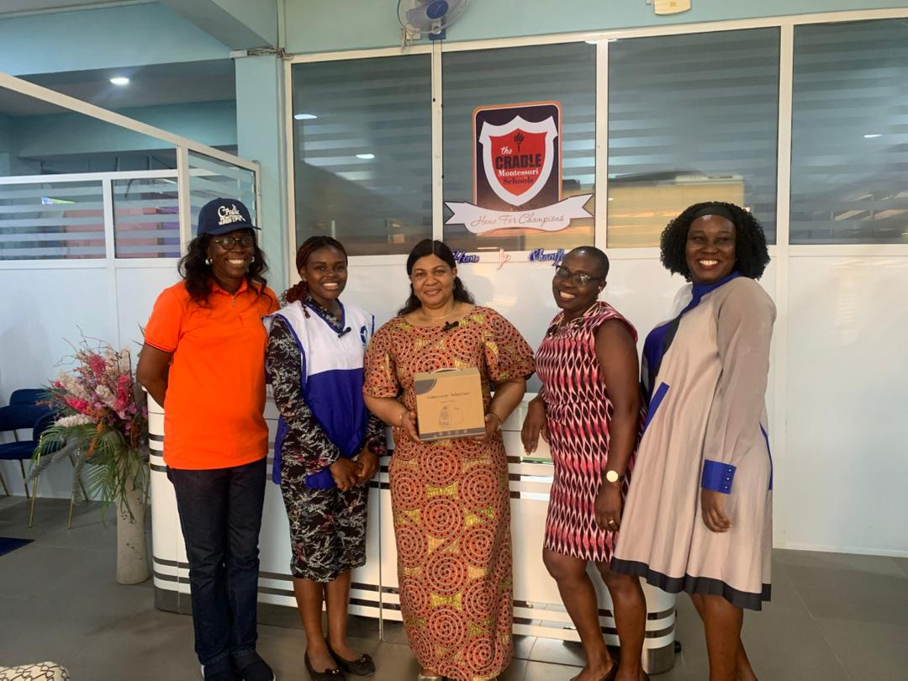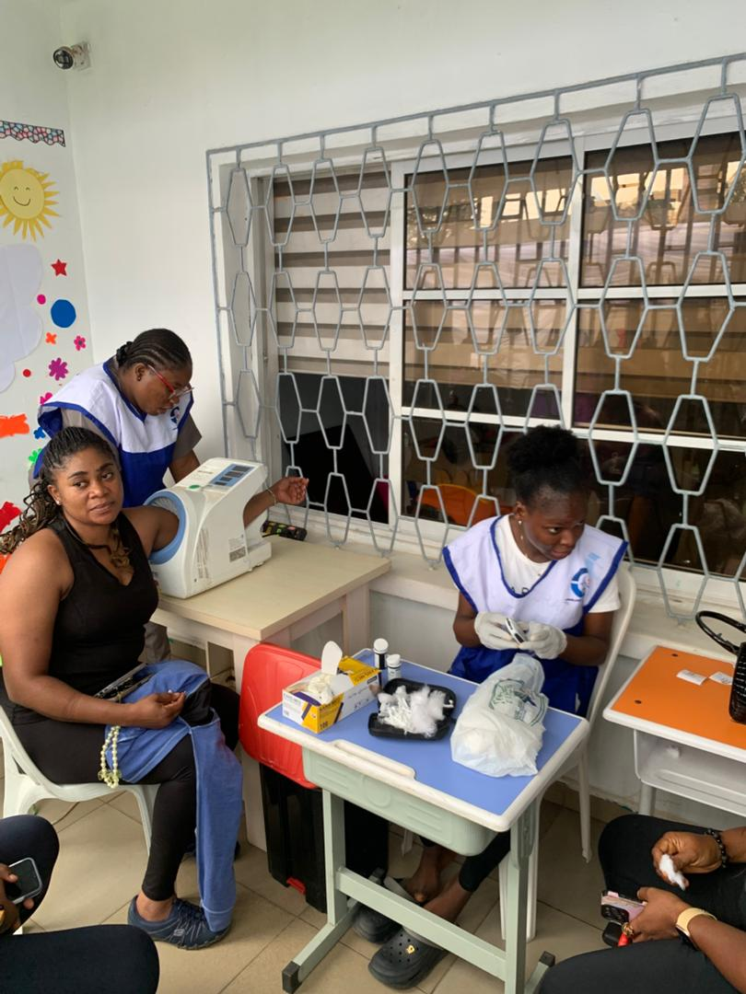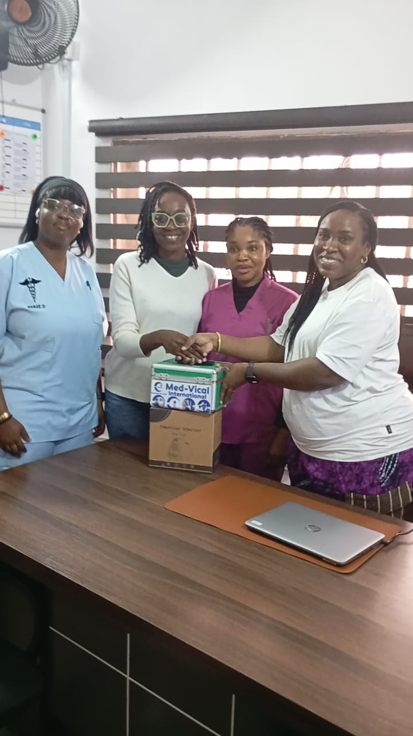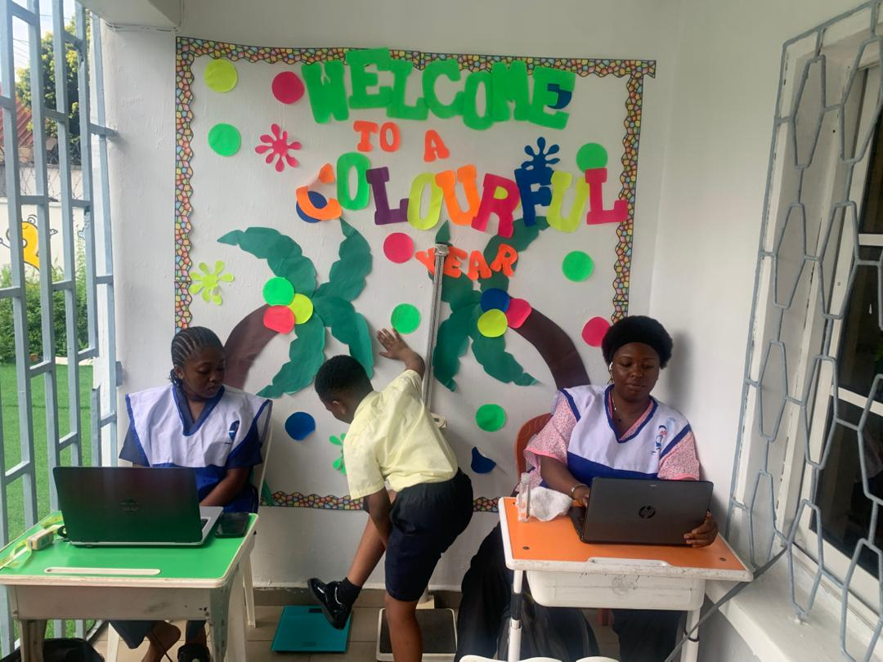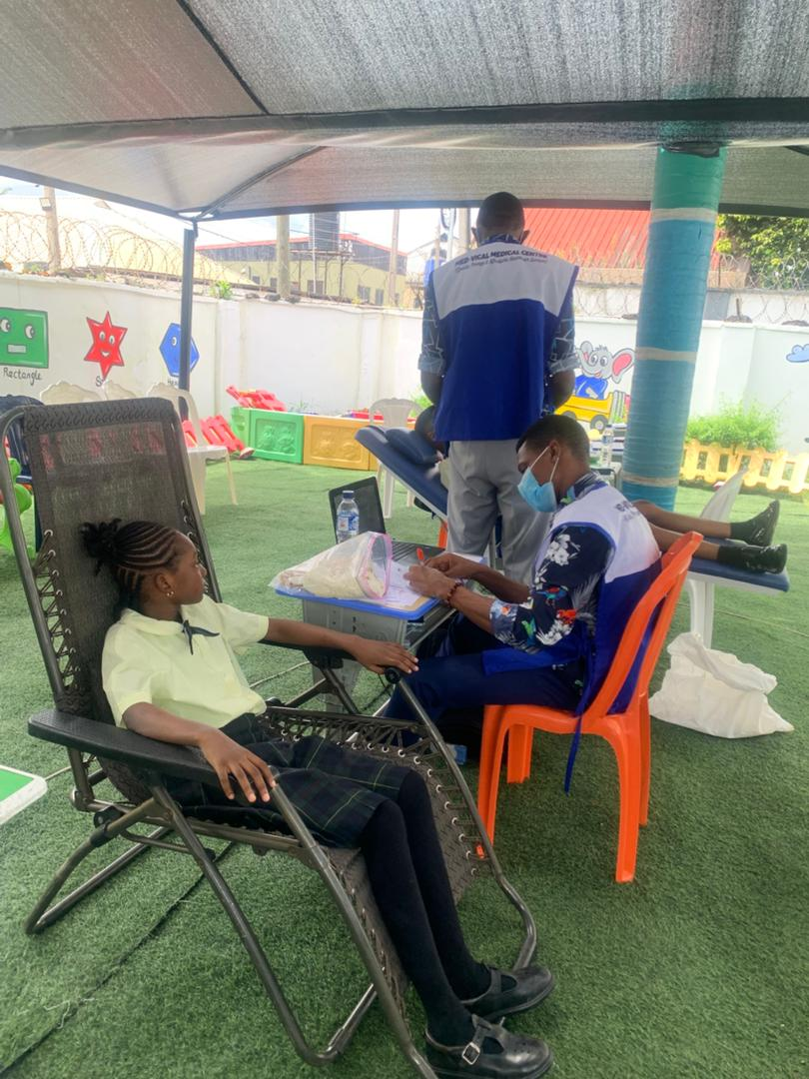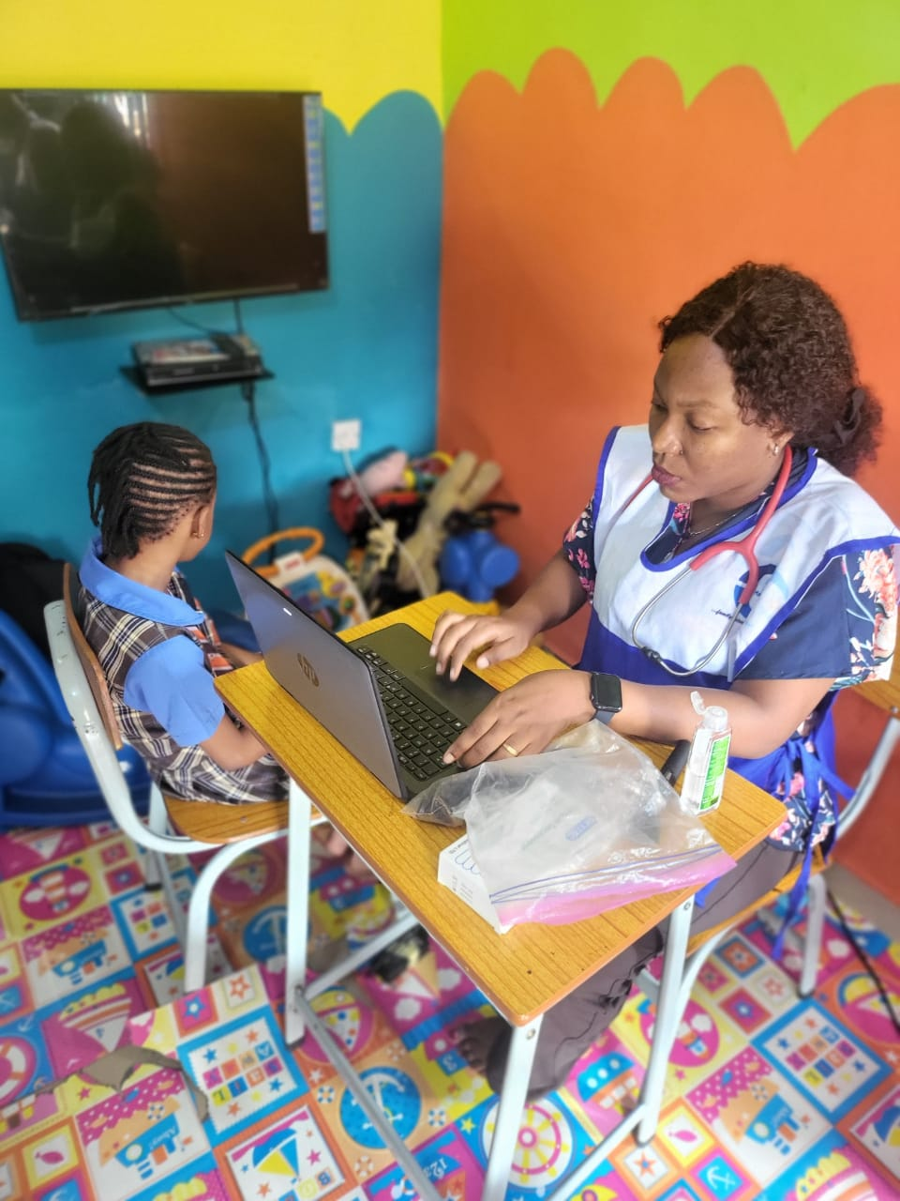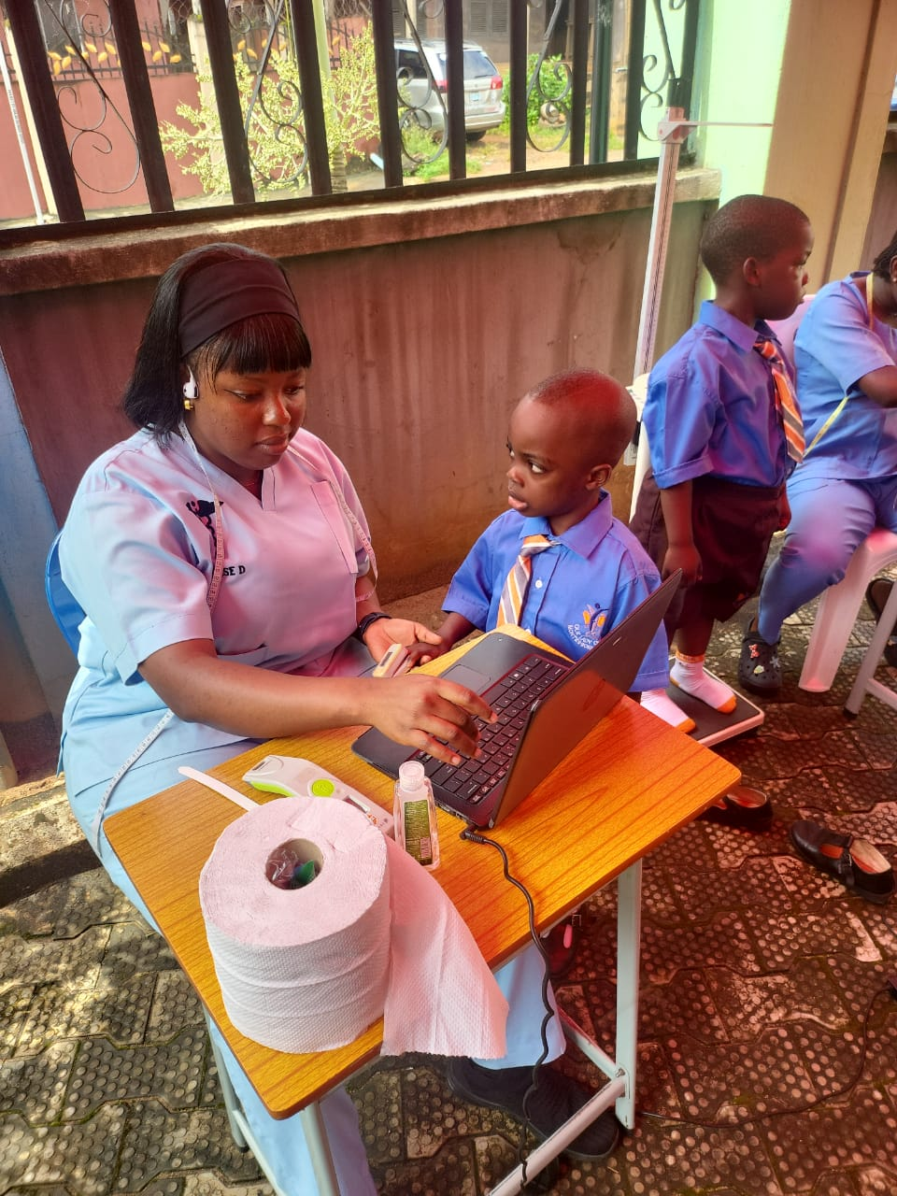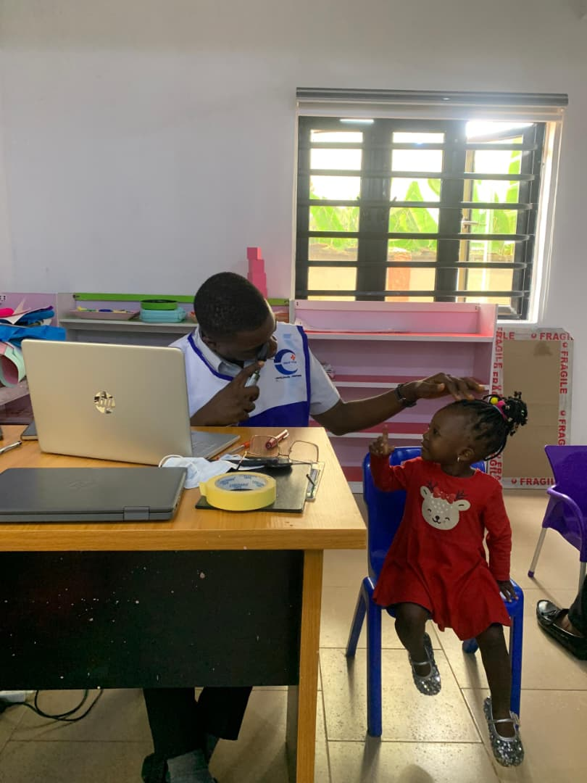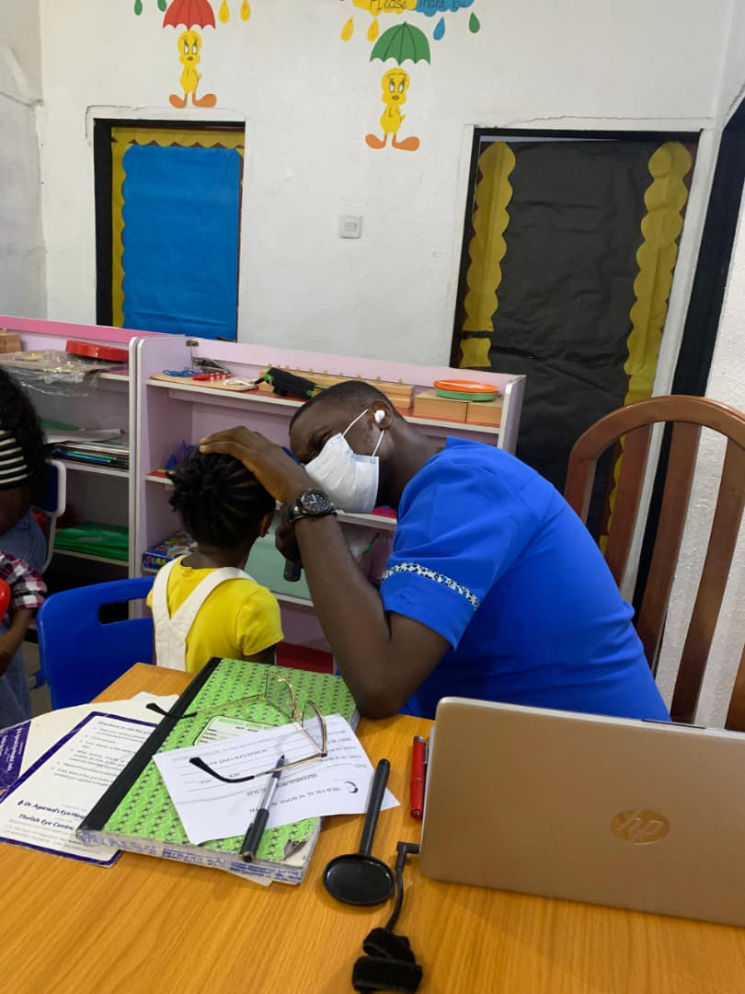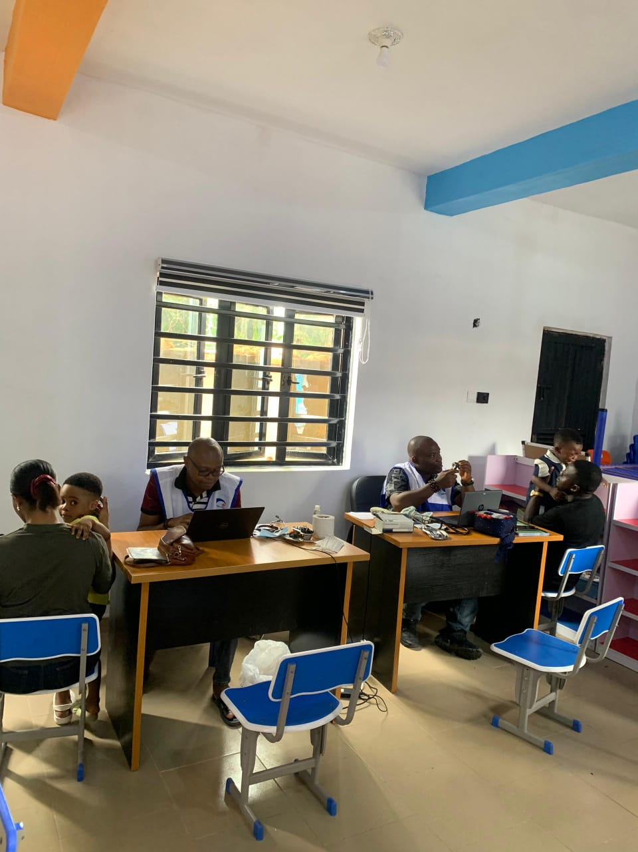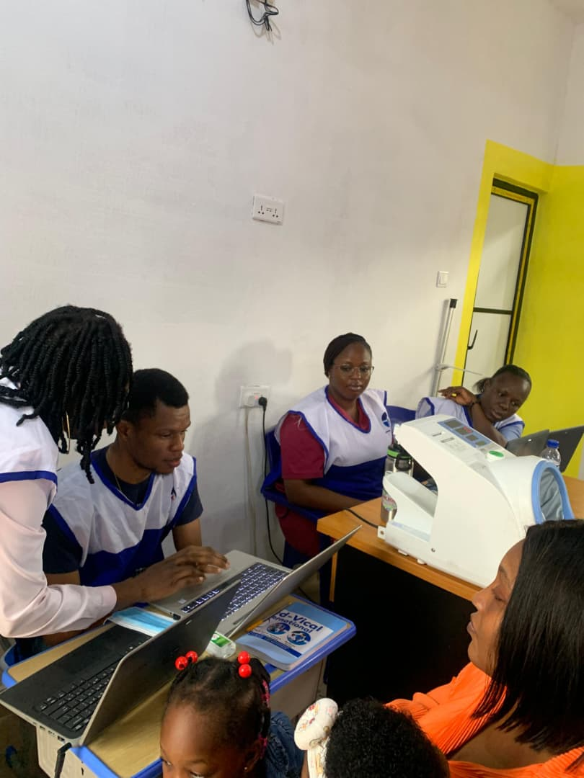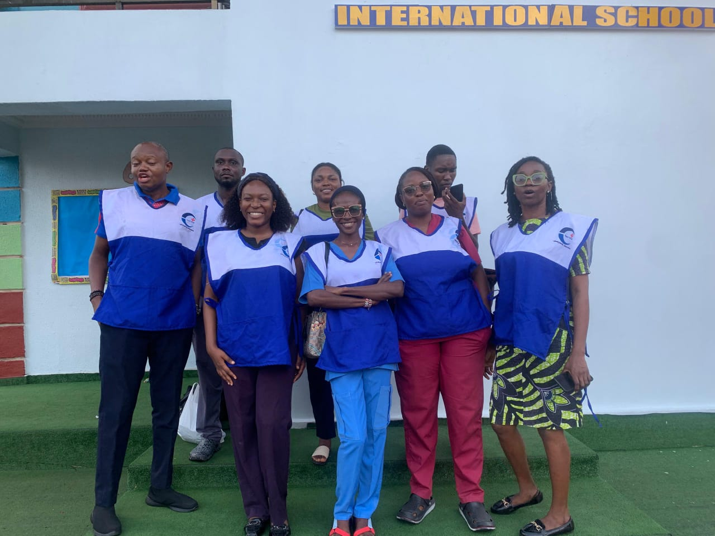

…………………………………………………………………………………………………………
Med-Vical School Health (MSH) Programme: Promoting Health and Educational Outcomes in Schools and Communities

For further information/inquiries, including request for partnership and/or sponsorship, contact us at:
Med-Vical International, #44 Boundary Road, GRA, Benin City
Email: info@medvical.com; medvicalschoolhealth@medivical.com;
Tel/WhatsApp: +234 9126976533/9019305059

